Perhaps you’ve never heard of Fairtrade Gold?

Maybe you didn’t even know such a thing existed?

Two very good reasons for visiting our Fairtrade Gold Exhibition:

What? A telling and informative exhibition of photographic images.

When? This exhibition will be available to view from 09.00 – 13.00 hrs on Monday to Friday 8 – 12 October

Where? Fellowship Hall, Springfield Cambridge Parish Church, 49 Springfield Rd, Bishopbriggs, Glasgow G64 1PN

Why? To find out how Fairtrade Gold improves the lives of gold miners and stops them being exploited purely for gain.

Fairtrade Certified Gold is the world's first independent ethical certification system for gold. Buying Fairtrade Gold makes a real difference to the lives of miners, their families and communities. It means that the small-scale and artisanal miners were paid a fair price, giving them financial security. You can be reassured that they work in fair conditions and are not forced to use toxic chemicals which are harmful to health.
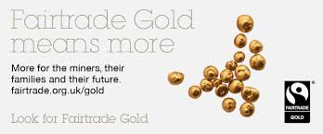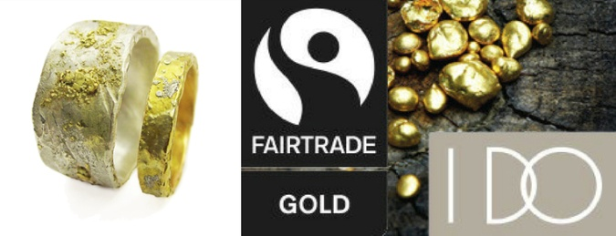

This exhibition is brought to you by the East Dunbartonshire Fair Trade Steering Group and will be available to view in various locations in East Dunbartonshire. Like our Facebook page to be sure you will be advised of any updates.

